Kevin Kennedy
10-9-13
- 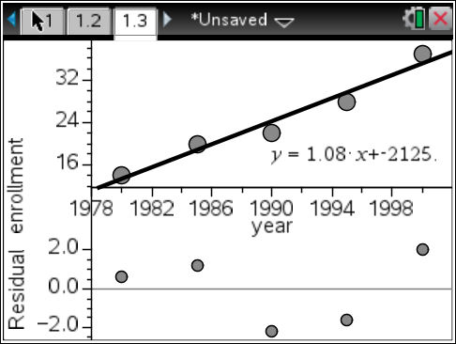
r = 0.978, there is no pattern in the residual plot
There is sufficient evidence to support a linear model between year and enrollment from 1980 to 2000 of this preschool.

- 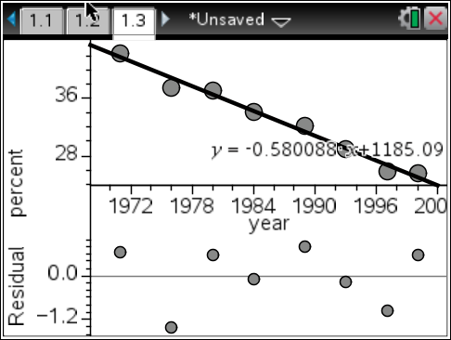
r = -0.991, there is no pattern in the residual plot
There is sufficient evidence to support a linear model between year and percent.
In the year 2009, roughly 19.8% of the adult population below the age of 25 will marry.

- 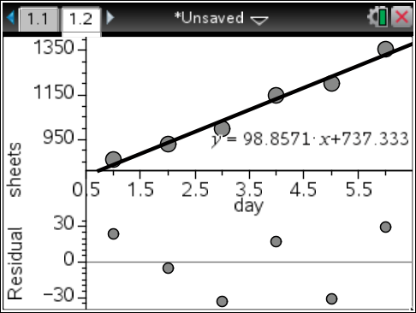
r = 0.98876, there is no pattern in the residual plot
There is sufficient evidence to support a linear model between.
The sheets will be shipped on the 13th day (x = 13.2784 when f(x) = 2050).

- 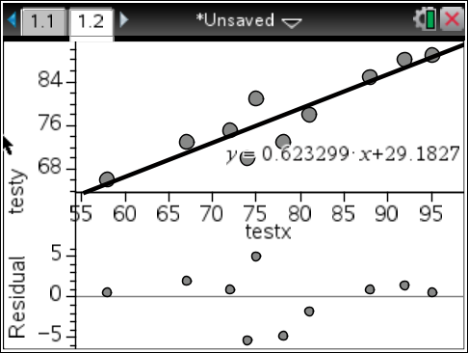
r = 0.915089, there is no pattern in the residual plot
There is sufficient evidence to support a linear model between Test X and Test Y.
b) A student who scored an 87 on Test X would most likely score an 83 on Test Y, according to the data.

- 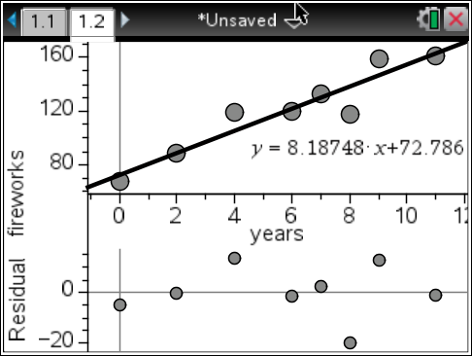
r = 0.943778, there is no pattern in the residual plot
There is sufficient evidence to support a linear model between number of years since 1990 and fireworks usage per year.
b) Fireworks usage would’ve reached 99 million pounds in the 3rd year (1993, x = 3.20172 when f(x) = 99).
c) By 2008, 220.2 millions of pounds of fireworks would’ve been used.

- 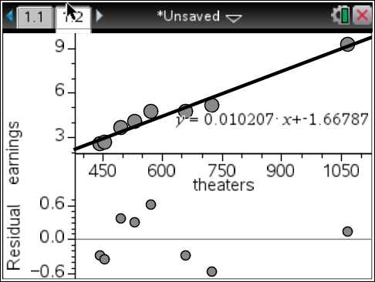
r = 0.980717, there is no pattern in the residual plot
There is sufficient evidence to support a linear model between Number of Theaters and Gross Earnings (millions).
b) According to the data, 610 theaters would earn 4.56 million dollars in one week.
c) According to the data, it would take approximately 913 (x = 912.89 when f(x) = 7.65) theaters to generate 7.65 million dollars in one week.

