1 | Virginia |  |  | 15 |  | 599 |  | 39.93
2 | Bryant |  |  | 19 |  | 745 |  | 39.21
3 | Duke |  |  | 21 |  | 798 |  | 38.00
4 | Albany (NY) |  |  | 18 |  | 669 |  | 37.17
5 | Cornell |  |  | 18 |  | 668 |  | 37.11
6 | Marist |  |  | 14 |  | 502 |  | 35.86
7 | North Carolina |  |  | 17 |  | 592 |  | 34.82
8 | Maryland |  |  | 14 |  | 470 |  | 33.57
9 | Delaware |  |  | 15 |  | 500 |  | 33.33
10 | Army |  |  | 14 |  | 463 |  | 33.07
11 | Mercer |  |  | 12 |  | 390 |  | 32.50
12 | Robert Morris |  |  | 15 |  | 487 |  | 32.47
13 | Quinnipiac |  |  | 14 |  | 451 |  | 32.21
14 | UMBC |  |  | 15 |  | 483 |  | 32.20
15 | Bucknell |  |  | 16 |  | 514 |  | 32.13
16 | Jacksonville |  |  | 13 |  | 413 |  | 31.77
17 | Villanova |  |  | 15 |  | 476 |  | 31.73
- | Georgetown |  |  | 15 |  | 476 |  | 31.73
19 | Johns Hopkins |  |  | 14 |  | 444 |  | 31.71
20 | Colgate |  |  | 15 |  | 473 |  | 31.53
21 | Sacred Heart |  |  | 14 |  | 441 |  | 31.50
22 | Fairfield |  |  | 15 |  | 471 |  | 31.40
- | Detroit |  |  | 15 |  | 471 |  | 31.40
24 | High Point |  |  | 15 |  | 470 |  | 31.33
25 | Siena |  |  | 17 |  | 532 |  | 31.29
26 | Princeton |  |  | 15 |  | 463 |  | 30.87
27 | Yale |  |  | 17 |  | 521 |  | 30.65
28 | Hobart |  |  | 14 |  | 429 |  | 30.64
29 | Navy |  |  | 13 |  | 398 |  | 30.62
30 | Loyola Maryland |  |  | 16 |  | 489 |  | 30.56
31 | Rutgers |  |  | 15 |  | 455 |  | 30.33
32 | Penn St. |  |  | 17 |  | 514 |  | 30.24
33 | Lehigh |  |  | 17 |  | 511 |  | 30.06
34 | St. John's (NY) |  |  | 13 |  | 389 |  | 29.92
35 | VMI |  |  | 13 |  | 385 |  | 29.62
36 | Brown |  |  | 14 |  | 414 |  | 29.57
37 | Hartford |  |  | 14 |  | 413 |  | 29.50
38 | Providence |  |  | 16 |  | 468 |  | 29.25
39 | Marquette |  |  | 13 |  | 380 |  | 29.23
40 | Canisius |  |  | 13 |  | 378 |  | 29.08
41 | Air Force |  |  | 14 |  | 407 |  | 29.07
42 | Ohio St. |  |  | 17 |  | 494 |  | 29.06
43 | Manhattan |  |  | 15 |  | 434 |  | 28.93
44 | Vermont |  |  | 14 |  | 404 |  | 28.86
45 | Drexel |  |  | 15 |  | 432 |  | 28.80
46 | Denver |  |  | 19 |  | 547 |  | 28.79
47 | Dartmouth |  |  | 14 |  | 399 |  | 28.50
48 | Syracuse |  |  | 20 |  | 568 |  | 28.40
49 | Massachusetts |  |  | 15 |  | 425 |  | 28.33
50 | Lafayette |  |  | 13 |  | 368 |  | 28.31
51 |  | Penn | 13 |  | 367 |  | 28.23
52 |  | Stony Brook | 16 |  | 444 |  | 27.75
53 |  | Binghamton | 14 |  | 387 |  | 27.64
54 |  | Bellarmine | 14 |  | 385 |  | 27.50
55 |  | Notre Dame | 16 |  | 430 |  | 26.88
56 |  | Hofstra | 14 |  | 370 |  | 26.43
57 |  | Harvard | 14 |  | 369 |  | 26.36
58 |  | Mt. St. Mary's | 15 |  | 391 |  | 26.07
59 |  | Holy Cross | 15 |  | 384 |  | 25.60
60 |  | Michigan | 14 |  | 356 |  | 25.43
61 |  | Wagner | 13 |  | 326 |  | 25.08
62 |  | Towson | 18 |  | 451 |  | 25.06
63 |  | Saint Joseph's | 16 |  | 375 |  | 23.44

1 | Syracuse |  |  | 16 |  | 4 |  | .800
2 | Cornell |  |  | 14 |  | 4 |  | .778
3 | Ohio St. |  |  | 13 |  | 4 |  | .765
- | North Carolina |  |  | 13 |  | 4 |  | .765
5 | Duke |  |  | 16 |  | 5 |  | .762
6 | Bucknell |  |  | 12 |  | 4 |  | .750
7 | Denver |  |  | 14 |  | 5 |  | .737
8 | Drexel |  |  | 11 |  | 4 |  | .733
9 | Albany (NY) |  |  | 13 |  | 5 |  | .722
10 | Marist |  |  | 10 |  | 4 |  | .714
- | Maryland |  |  | 10 |  | 4 |  | .714
12 | Yale |  |  | 12 |  | 5 |  | .706
- | Penn St. |  |  | 12 |  | 5 |  | .706
- | Lehigh |  |  | 12 |  | 5 |  | .706
15 | St. John's (NY) |  |  | 9 |  | 4 |  | .692
16 | Loyola Maryland |  |  | 11 |  | 5 |  | .688
- | Notre Dame |  |  | 11 |  | 5 |  | .688
18 | Johns Hopkins |  |  | 9 |  | 5 |  | .643
19 | Penn |  |  | 8 |  | 5 |  | .615
- | Jacksonville |  |  | 8 |  | 5 |  | .615
21 | Princeton |  |  | 9 |  | 6 |  | .600
22 | Brown |  |  | 8 |  | 6 |  | .571
- | Army |  |  | 8 |  | 6 |  | .571
24 | Towson |  |  | 10 |  | 8 |  | .556
25 | Colgate |  |  | 8 |  | 7 |  | .533
- | Fairfield |  |  | 8 |  | 7 |  | .533
- | Robert Morris |  |  | 8 |  | 7 |  | .533
28 | Bellarmine |  |  | 7 |  | 7 |  | .500
- | Hofstra |  |  | 7 |  | 7 |  | .500
- | Air Force |  |  | 7 |  | 7 |  | .500
- | Hartford |  |  | 7 |  | 7 |  | .500
- | Providence |  |  | 8 |  | 8 |  | .500
33 | Siena |  |  | 8 |  | 9 |  | .471
34 | Massachusetts |  |  | 7 |  | 8 |  | .467
- | UMBC |  |  | 7 |  | 8 |  | .467
- | Holy Cross |  |  | 7 |  | 8 |  | .467
- | Virginia |  |  | 7 |  | 8 |  | .467
- | Villanova |  |  | 7 |  | 8 |  | .467
39 | Stony Brook |  |  | 7 |  | 9 |  | .438
40 | Quinnipiac |  |  | 6 |  | 8 |  | .429
- | Harvard |  |  | 6 |  | 8 |  | .429
- | Hobart |  |  | 6 |  | 8 |  | .429
43 | Bryant |  |  | 8 |  | 11 |  | .421
44 | Mt. St. Mary's |  |  | 6 |  | 9 |  | .400
- | Georgetown |  |  | 6 |  | 9 |  | .400
46 | Marquette |  |  | 5 |  | 8 |  | .385
47 | Binghamton |  |  | 5 |  | 9 |  | .357
48 | Detroit |  |  | 5 |  | 10 |  | .333
- | Mercer |  |  | 4 |  | 8 |  | .333
- | Delaware |  |  | 5 |  | 10 |  | .333
51 |  | Saint Joseph's | 5 |  | 11 |  | .313
52 |  | Vermont | 4 |  | 10 |  | .286
53 |  | Manhattan | 4 |  | 11 |  | .267
54 |  | Canisius | 3 |  | 10 |  | .231
- |  | Navy | 3 |  | 10 |  | .231
- |  | Lafayette | 3 |  | 10 |  | .231
57 |  | Dartmouth | 3 |  | 11 |  | .214
- |  | Sacred Heart | 3 |  | 11 |  | .214
59 |  | High Point | 3 |  | 12 |  | .200
60 |  | Rutgers | 2 |  | 13 |  | .133
61 |  | VMI | 1 |  | 12 |  | .077
- |  | Wagner | 1 |  | 12 |  | .077
63 |  | Michigan | 1 |  | 13 |  | .071

Original 20 teams

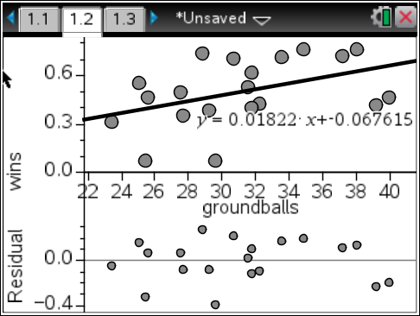

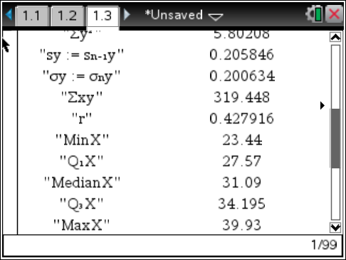

Removed outliers Denver, Virginia, Bryant – 17 teams

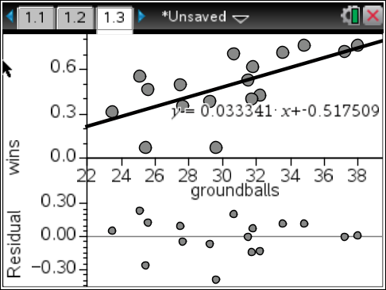
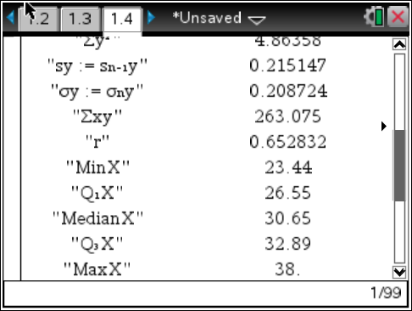
In my original scatterplot with my 20 randomly selected teams, my “r” came out to be 0.427916 while the α = .05 significance level in the back of the book was 0.444 for n = 20. This gave me a weak positive correlation.
What this means is that there is no significant evidence to support a linear model between the average number of groundballs a team gets in a game compared to a team’s win percentage in a season.

Although, I was able to remove three major outliers from my data:
University of Denver – in the 2013 season Denver had one of the most efficient offenses of that year. During this season, Denver ranked Number 6 in Scoring Offense in NCAA D1 of the 2013 season according to NCAA.com. So logically speaking, Denver was winning a lot of games, but on the other hand they were not dropping the ball very much because they had a very skilled offense and didn’t create as many groundball opportunities as other teams did, meanwhile they were still scoring and putting up the goals which led them to their wins, resulting in them being an outlier.
Bryant University – according to the stats of NCAA D1 on NCAA.com Bryant University was Number 1 in two categories, highest faceoff win percentage as a team at 72.8% and they also held the number one man in the nation at faceoffs which in turn led to the number one man in the nation at getting ground balls, Kevin Massa. Massa was a sophomore in the 2013 seasons and he tore up the record books. He led the nation in ground balls with a total of 231 in just 19 games, which also gave him the highest ground balls per game stat, at 12.16 ground balls per game. Although Kevin Massa was winning faceoffs and scooping up the groundballs, his offense and defense didn’t do as well as he did, resulting in Bryant being a mediocre team at best, but still being great with ground balls thanks to one man, resulting in them being an outlier.
University of Virginia – Although Virginia has been a powerhouse throughout their history of lacrosse, in the 2013 season this just wasn’t the case. Virginia had the most groundballs last season per game out of any other D1 team at 39.93 ground balls per game, but had one of the lower win percentages at a .467 win percentage. Virginia had no extremely talented players but obviously had players that worked hard for every ground ball. Which most likely resulted in their offense dropping the ball a lot and picking it back up (which would still count as a groundball). So this allowed them to pad their stats in the groundball department, but the lack of passing and catching would also result in lower goals scored per game, which led the Cavaliers to become a losing team rather than a winning one, resulting in them being an outlier.

In my new set of data with 17 teams, after removing the three outliers, I was able to create a much more positive linear correlation. My new set of data gave me an “r” of 0.652832, and the α = .05 significance level for n = 17 in the back of the book was 0.482.
This new set of data without outliers proved to be an immense difference, and gave me a strong positive correlation. It also proved that there was significant evidence to support the linear model between a team’s groundballs per game and a team’s overall win percentage of that season.
Conclusions that I have made about the data are that while the outliers remained within the data, there was still a weak positive correlation between my two variables. With the outliers removed, we can see that there is an exceptionally strong positive correlation between the X and Y axis. So whether the outliers remained in the data or not, we can see that there is some sort of correlation with groundballs you get in a game and how many wins you can produce. Although your offense and defense is what wins you game, groundballs essentially decides who will have more possession on offense, and usually the team who has the ball longer will generate more goals and be scored on less, resulting in a win.
This information was completely useful to me and my life. I currently play lacrosse for Siena Heights University and I played all throughout high school. In all of my years of lacrosse and the four different head coaches I have had, every single one of them has uttered the same phrase at one point or another: “ground balls win games.” That is all I heard from when I started playing lacrosse, and I still here it to this day. The more groundballs you get, the more likely you are to win, it’s that simple. I did this experiment in this class for this exact purpose, I wanted to find out if this was true. To this day in college lacrosse, Coach Maloney gets our stats printed off at halftime and only tells us on of them: groundballs. He tells us whether we won or lost the groundball battle of that half, and we plan how we play that second half according to those stats. Our main goal in every game is to be winning the groundball battle, because it is always said it will result in a win.
This experiment that I have done here has explained that almost perfectly. With these strong positive correlations I have concluded that groundballs do in fact have an effect on wins. With the data before us I can make predictions that the more groundballs a team has will result in more wins. The higher the groundballs per game a team has the more likely they are to pull out a victory. Of course a team can have other variables such as a good faceoff man, a bad offense/defense or a bad goalie, which result in more losses than are needed, but the end result remains the same, the more groundballs that a team gets in a game, the more likely that team is going to win.

